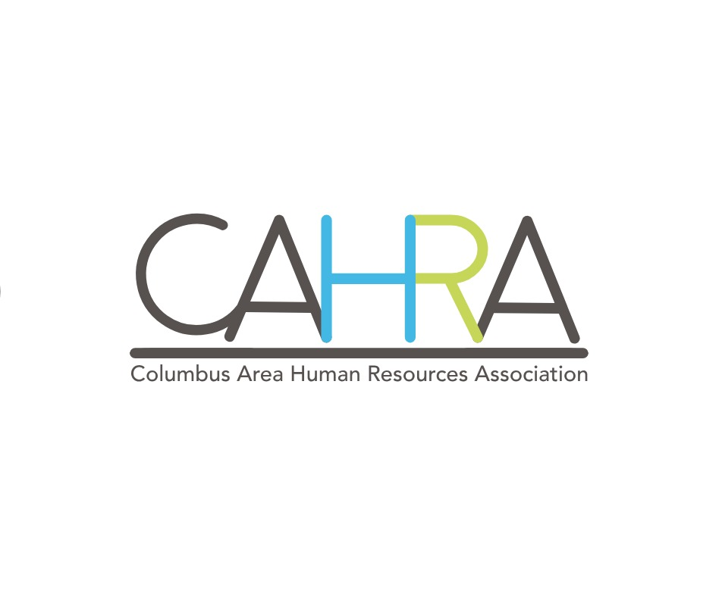

CAHRA Monthly Meeting Minutes – January 19, 2023

There were 28 members who attended the CAHRA meeting via Zoom. Meeting was only zoom due to the weather.

President’s Report:
- LHRMA – Small Brave Moves presented by Nicole Bianchi in Lincoln, NE on February 7th (see attached) CAHRA will offer one scholarship. Will do a drawing for those interested.
- State Conference is August 16 – 18, 2023 in LaVista. Registration is open. CAHRA will get one free registration from the State.

Approval of Minutes
- The minutes of the October meeting were approved by Michelle Meyer and seconded by Amanda Henry.

Treasurer’s Report
- No report

Legislative Committee Report
- New minimum wage in affect make sure you have your new posters displayed
- Secure 2.0 changes to 401(k) plans – make sure to review your plan statement for changes
- 108th legislation is in session and will be continuing to monitor bills that impact HR

Scholarship Committee
- No report

Membership Report
- We’ve had a few new members join or re-join:
  - Danielle Ortmeier – Columbus Hydraulics
  - Carrie Horejsi – NPPD
  - Jennifer Guillen – Valmont Industries
  - Becky (Rebecca) Sindelar – Sanford Health/Good Samaritan Society

- If you have not turned in your 2023 Membership Registration form yet, the Early Bird drawing has been extended to February 3, 2023. Please mail your form and money to:
CAHRA
Attn: Membership Committee
P.O. Box 23
Columbus, NE 68601
Programs:
- Today’s Guest Speaker was Hannah Miller with Nebraska VR. Hannah gave a very informative presentation on Windmills Training. See attached flyer for more details.
- Today’s Legal Update was presented by Christopher Hoyme, Principal with Jackson Lewis.
- If you have an idea for future programs, please contact Chantel Vonasek or Abby Sliva.

Upcoming Topics/Meetings/Events:
- February 16th – Nebraska Department of Labor presentation given by Kim Neesen.
- Suicide Prevention Coalition – Baskets for Hope Fundraiser is March 25th. They are asking for donations (see attached).

Certification Credits
- In order to retain your certification, members are responsible for entering their own certification credits for SHRM and HRCI. If you need certification credits, please contact Andra Vandenberg at andra@vandenbergelectric.com

Respectfully submitted,
Tammy Orender
CAHRA Secretary
CAHRA2017@gmail.com

2023 CAHRA OFFICERS
Kristel Hall, President Melinda Allen, Vice President
Doris Wemhoff, Treasurer Tammy Orender, Secretary
Chantel Vonasek &Abby Sliva, Programs Co-Chairs Amanda Henry, Legislature Chair
Jessie Kinnett, Social Media and Public Relations Chair Riki Schnell, Scholarships Co-Chairs
Andra Vandenberg, Certification Chair Michelle Meyer, Membership Chair

